Installing MagicDNA
Here is the information to install MagicDNA. This should work for anyone who has access to Matlab (2017 or newer) on a laptop. You can download the software here:
https://github.com/cmhuang2011/MagicDNA (Links to an external site.)
The easiast way to do it is to download the matlab app install file:
https://www.dropbox.com/s/8rvsmswilwgpbk0/MagicDNA_installation.zip?dl=0Links to an external site.
This zip folder has both the user manual and a file called "MagicDNA_v2.0.2_03212020.mlappinstall". This is the file you will need you will use to install MagicDNA. You can just drag and drop the file into the Matlab command window, and it should install automatically. Once it installs, you should see it in the list of Apps when you click on the Apps tab in the top left.
Once the app installs, it will initially stall in your Matlab add-ons folder. That is buried deep in other folders (you can see path if you hover your cursor over the app button in matab, see below). MagicDNA will write files to the same folder, so it is more convenient to copy the MagicDNA folder to a more accessible folder. Then set the new folder as your current directory in Matlab.
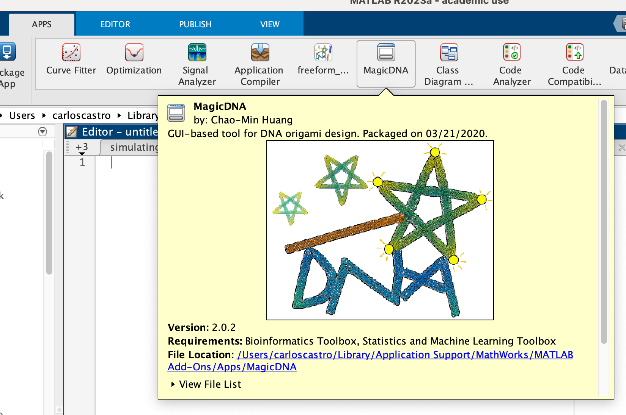
Here is a video that shows you how to install:
MagicDNA_install_GMT20220803-043933_Recording.mp4Links to an external site. (password is "magicdna")
Let us know if you have any trouble.
Toolboxes that you will need for Matlab:
statistics and machine learning toolbox + bioinformatics toolbox
Note: There may be some compatibility issues with Matlab 2024b. Works with 2023A or 2024A.
Some MagicDNA Examples and Tutorials: https://www.youtube.com/@magicdnasoftware1558/playlistsLinks to an external site.

